Practice 6.3: Writing Cube Root and Cubic Equations from Graphs and Descriptions & Analyzing Intervals
Algebra 2

Write an equation for each description.

1) The function $f(x)=\sqrt[3]{x}$ reflected over the x-axis, translated left by 2, down 1, and horizontally compressed by a factor of ½ . Write the new function $g(x).$

2) The function $f(x)=\sqrt[3]{x}$ reflected over the y-axis, translated right by 2, up 3, and vertically compressed by a factor of ½ . Write the new function $g(x).$

3) The function $f(x)=x^{3}$ reflected over the x-axis, translated right by 2, down 1, and horizontally compressed by a factor of ½ . Write the new function $g(x).$

4) The function $f(x)=x^{3}$ reflected over the y-axis, translated right by 2, up 3, and vertically compressed by a factor of ½ . Write the new function $g(x).$

Write an equation for each graph.
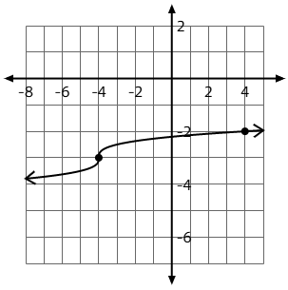
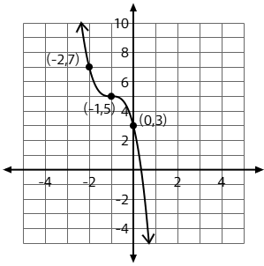
5) 6)

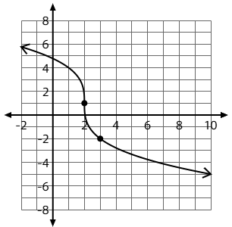
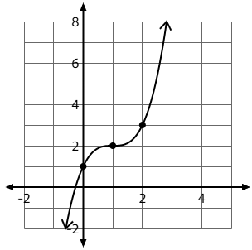
7) 8)

Given an interval, provide the requested information.
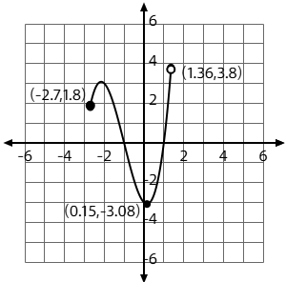
9) For the graph at the right, identify the following:
Domain:

Range:

x-intercept(s):

y-intercept(s):

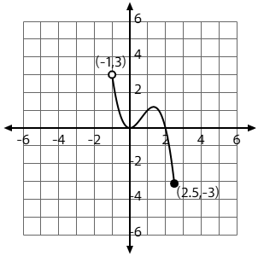
10) For the graph at the right, identify the following:
Domain:

Range:

x-intercept(s):

y-intercept(s):

